CHAPTER 9: Energy transmission
Worksheet 9.2

Reflection and scattering of light
Science Quest 9: pages 314–19
Student: Class:

Locating the virtual image
1. An object (O) is observed by looking at the rays of light reflecting off a plane mirror. The mirror consists of a plate of glass with a silver back surface mounted on a sheet of wood.

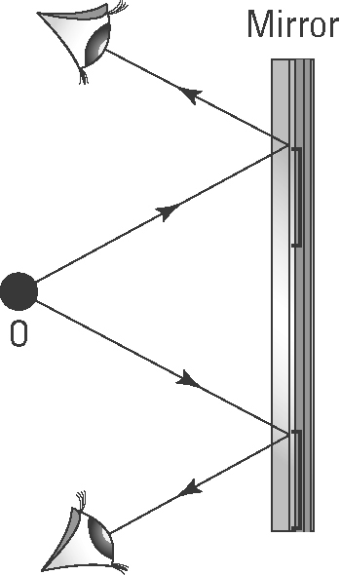
(a) Use a ruler and pencil to extend each reflected ray (using dotted lines) until they intersect behind the mirror. Label the point of intersection as ‘virtual image’.
(b) Complete the sentence:
The object in front of a reflecting surface and a virtual image are the ………… distance from a mirror.
(c) Draw the normal to the mirror surface and measure the incident and reflected angles for the ray above the object, O.

Light and air
2. The diagram below shows the collision of light rays with particles of air in the atmosphere. Use the letters X, Y and Z to identify the following rays.
Scattered: ...........................
Incident: .............................
Transmitted: .........................
